ISLAMIC UNIVERSITY OF TECHNOLOGY

Organization of Islamic Cooperation

Board Bazar, Gazipur

Lab Final Exam

CSE 4512

**Step 0**:

1. Ping result (from PC0 to Web Server)

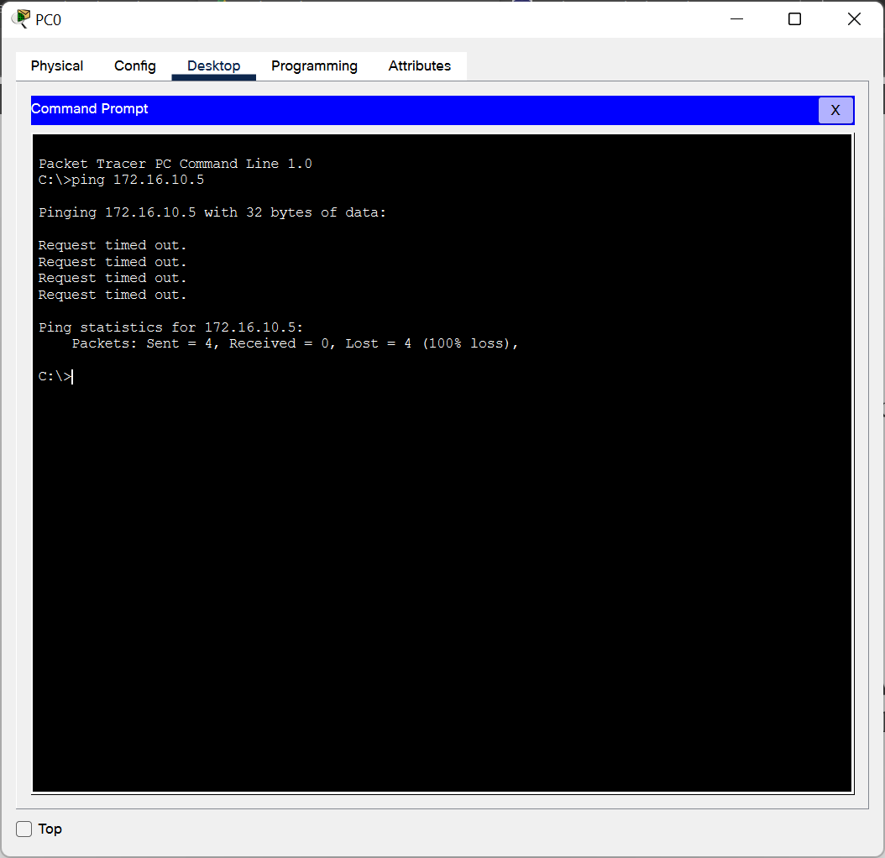

**Step 1 (NAT)**:

1. Ping result after NAT configuration (from PC0 to Web Server)

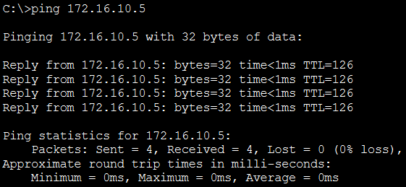

1. Command output after above ping (show ip nat translations)

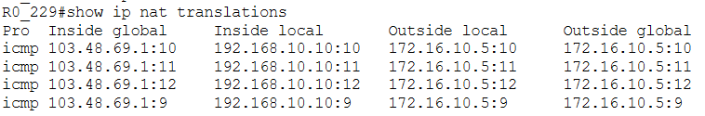

Ping result after NAT configuration (from Attacker laptop to Mail Server)

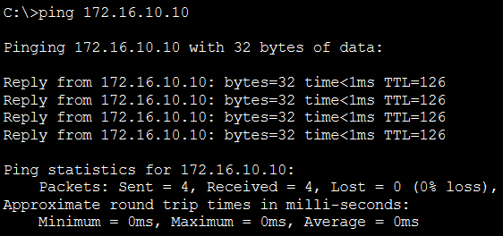

1. Command output after above ping (show ip nat translations)

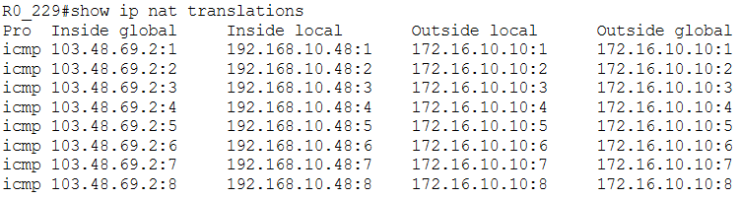

**Step 2 (Switch Port Security)**:

1. Command output after disabling all unused ports (show ip interface brief)

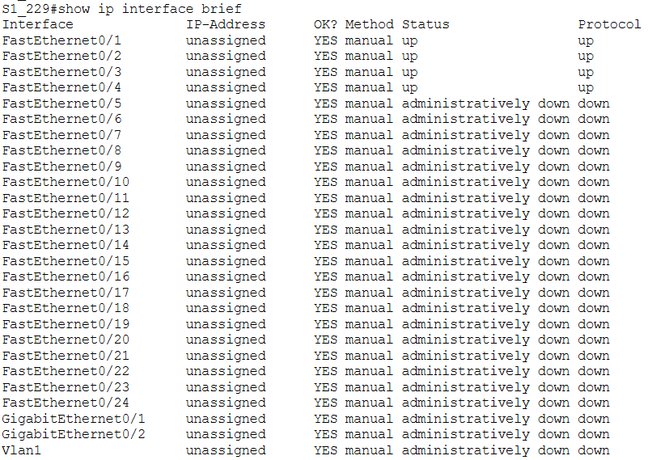

1. Command output after configuring switch port security (show port-security)

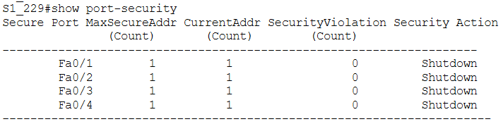

1. Command output after configuring switch port security (show port-security address)

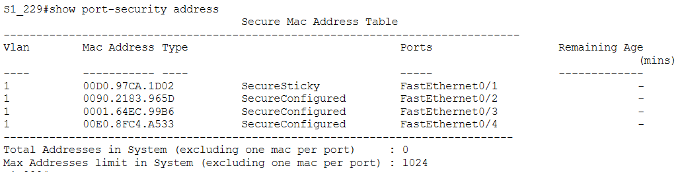

1. Screenshot of whole topology after ping (from Intruder laptop to Web Server)

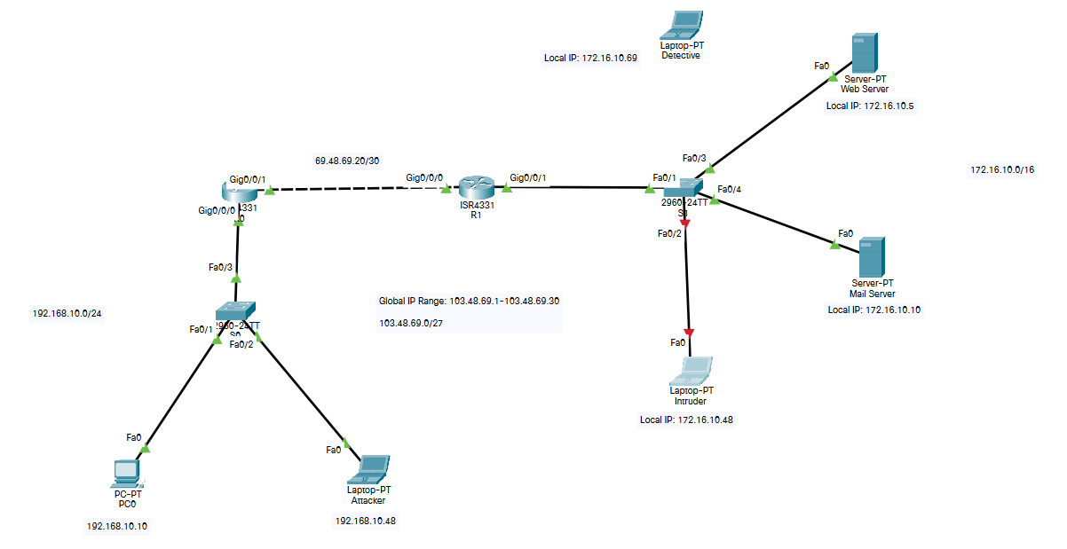

1. Command output after security violation from Intruder laptop (show port-security)

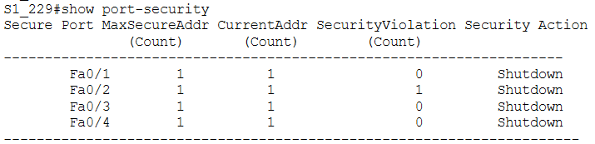

**Step 3 (SPAN)**:

1. Command output after configuring SPAN (show monitor)

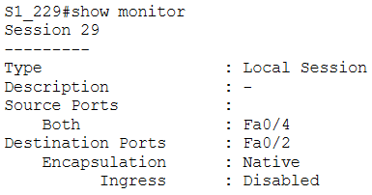

**Step 4 (ACL)**:

1. Ping result after configuring ACL (from Attacker laptop to Mail Server)

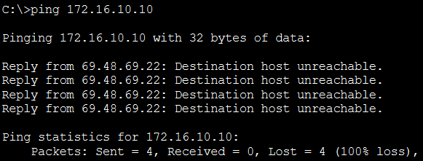

1. Command output after configuring ACL (show access-lists)

